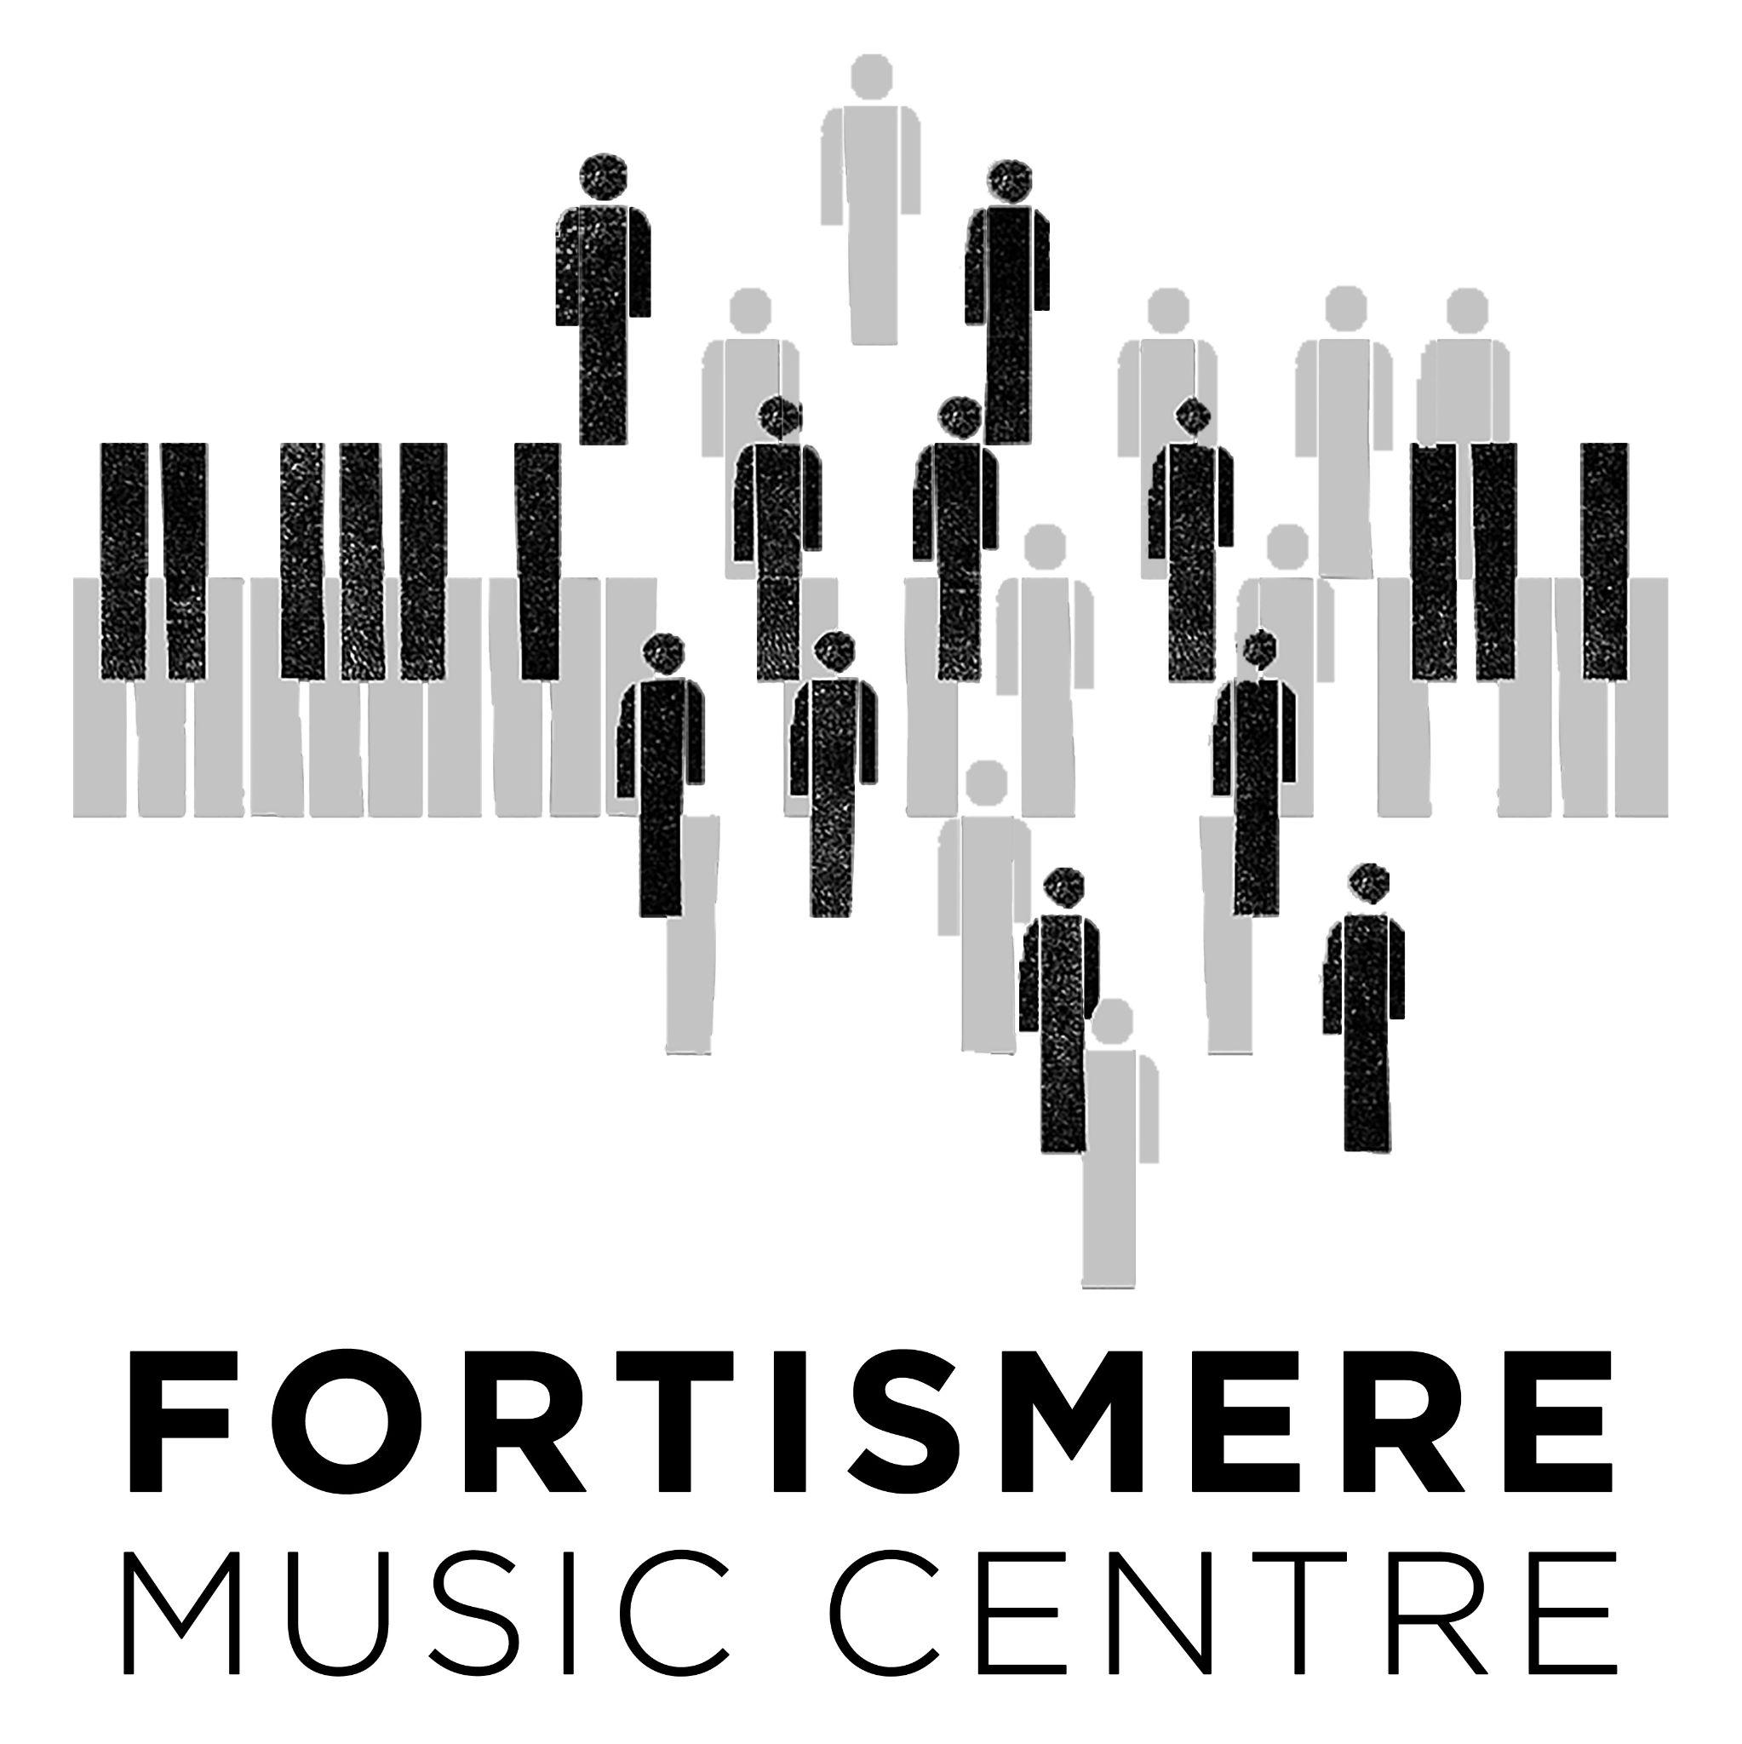
Privacy and Cookies Policy
Your privacy is important to us. It is Fortismere Music Centre’s policy to respect your privacy regarding any information we may collect from you across our website, https://www.fortismeremusiccentre.co.uk, and other sites we own and operate.
INFORMATION WE COLLECT
Log data
When you visit our website, our servers may automatically log the standard data provided by your web browser. This data is considered “non-identifying information”, as it does not personally identify you on its own. It may include your computer’s Internet Protocol (IP) address, your browser type and version, the pages you visit, the time and date of your visit, the time spent on each page, and other details.
We may also collect data about the device you are using to access our website. This data may include the device type, operating system, unique device identifiers, device settings, and geo-location data. What we collect can depend on the individual settings of your device and software. We recommend checking the policies of your device manufacturer or software provider to learn what information they make available to us.
Personal information
We may ask for personal information, such as your:
- Name
- Email
- Social media profiles
- Date of birth
- Phone/mobile number
- Home/Mailing address
- Work address
- Payment information
This data is considered “identifying information”, as it can personally identify you. We only request personal information relevant to providing you with a service, and only use it to help provide or improve this service.

USE OF INFORMATION
We may use a combination of identifying and non-identifying information to understand who our visitors are, how they use our services, and how we may improve their experience of our website in future. We do not disclose the specifics of this information publicly, but may share aggregated and anonymised versions of this information, for example, in website and customer usage trend reports.
We may use your personal details to contact you with updates about our website and services, along with promotional content that we believe may be of interest to you. If you wish to opt out of receiving promotional content, you can follow the “unsubscribe” instructions provided in any promotional correspondence from us.
Use of images
In order to inform the community about the range of activities provided at Fortismere Music Centre (FMC), the Centre needs to be able to take photographs, videos and recordings of users of the Centre and publish these in flyers and other publicity materials, on social media and the FMC website. We might also include images of the choir, orchestra and other users on displays around the school, at events or in the local community, or in press releases to local newspapers/journals.
This is a vital aspect of the Centre’s work to increase awareness, funding for and participation in the Centre. If we use images, we will not use the full or partial name of individuals in the accompanying text unless their consent has been given for that specific usage. Group images will have very general labels, such as ‘choir concert’ or ‘orchestra rehearsal’. We will never include personal email addresses or telephone numbers on our website, or in FMC publications.
Any images/recordings created by the school will remain the property of the school. Some images/recordings may be kept permanently once they are published and be kept as an archive of FMC life. You can ask FMC to stop using your image by emailing fmcinfo@fortismere.org.uk in which case it will not be used in future publications and will where practicable be removed from public view.
DATA PROCESSING AND STORAGE
The personal information we collect is stored and processed where we or our partners, affiliates and third-party providers maintain facilities. We only transfer data within jurisdictions subject to data protection laws that reflect our commitment to protecting the privacy of our users.
We only retain personal information for as long as necessary to provide a service, or to improve our services in future. While we retain this data, we will protect it within commercially acceptable means to prevent loss and theft, as well as unauthorised access, disclosure, copying, use or modification. That said, we advise that no method of electronic transmission or storage is 100% secure, and cannot guarantee absolute data security.
If user data becomes no longer relevant to our operations (for example, in the case of deleting your user account), we will retain it for a maximum of 30 days before deleting it from our active systems and backups. We do not store personal information in our archives.
COOKIES
We use “cookies” to collect information about you and your activity across our site. A cookie is a small piece of data that our website stores on your computer, and accesses each time you visit, so we can understand how you use our site. This helps us serve you content based on preferences you have specified.
If you don’t wish to accept cookies from us, you should instruct your browser to refuse cookies from https://www.fortismeremusiccentre.co.uk, with the understanding that we may be unable to provide you with some of your desired content and services.
THIRD-PARTY ACCESS TO INFORMATION
We use third-party services for:
- Analytics tracking
- User authentication
- Content marketing
- Email marketing
- Payment processing
These services may access our data solely for the purpose of performing specific tasks on our behalf. We do not share any personally identifying information with them without your explicit consent. We do not give them permission to disclose or use any of our data for any other purpose.
We may, from time to time, allow limited access to our data by external consultants and agencies for the purpose of analysis and service improvement. This access is only permitted for as long as necessary to perform a specific function. We only work with external agencies whose privacy policies align with ours.
We will refuse government and law enforcement requests for data if we believe a request is too broad or unrelated to its stated purpose. However, we may cooperate if we believe the requested information is necessary and appropriate to comply with legal process, to protect our own rights and property, to protect the safety of the public and any person, to prevent a crime, or to prevent what we reasonably believe to be illegal, legally actionable, or unethical activity.
We do not otherwise share or supply personal information to third parties. We do not sell or rent your personal information to marketers or third parties.
CHILDREN’S PRIVACY
We are committed to protecting the privacy of children who use our services. We encourage parents to engage with us in protecting their children’s privacy, ensuring a safe and enjoyable online experience.
LIMITS OF OUR POLICY
This privacy policy only covers Fortismere Music Centre’s own collecting and handling of data. We only work with partners, affiliates and third-party providers whose privacy policies align with ours, however we cannot accept responsibility or liability for their respective privacy practices.
Our website may link to external sites that are not operated by us. Please be aware that we have no control over the content and policies of those sites, and cannot accept responsibility or liability for their respective privacy practices.
CHANGES TO THIS POLICY
At our discretion, we may change our privacy policy to reflect current acceptable practices. We will take reasonable steps to let users know about changes via our website. If you are a registered user on https://www.fortismeremusiccentre.co.uk, we will notify you using the contact details saved in your account. Your continued use of this site after any changes to this policy will be regarded as acceptance of our practices around privacy and personal information.
YOUR RIGHTS AND RESPONSIBILITIES
As our user, you have the right to be informed about how your data is collected and used. You are entitled to know what data we collect about you, and how it is processed. You are entitled to correct and update any personal information about you, and to request this information be deleted. You may amend or remove your account information at any time, by emailing us at fmcinfo@fortismere.org.uk.
You are entitled to restrict or object to our use of your data, while retaining the right to use your personal information for your own purposes. You have the right to opt out of data about you being used in decisions based solely on automated processing.
If you have any concerns or questions about how we handle your data and personal information, feel free to contact us at fmcinfo@fortismeremusiccentre.co.uk.
This policy is effective as of 14/11/2023.

